European Youth Ultimate Championships 2017

Championship
View full bracket results
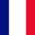
FRA U17 Men's
1st
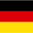
GER U17 Men
2nd
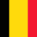
BEL U17 Men
3rd
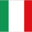
ITA U17 Men
4th
GBR U17 Men
5th
CZE U17 Men
6th
AUT U17 Men
7th
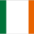
IRL U17 Men
8th
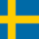
SWE U17 Men
9th
SUI U17 Men
10th
ISR U17 Men's
11th (tie)
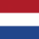
NED U17 Men
11th (tie)

